Chapter 17, Problem 8.

Using Fig. 17.51, design a problem to help other students better understand how to determine the exponential Fourier Series from a periodic wave shape.
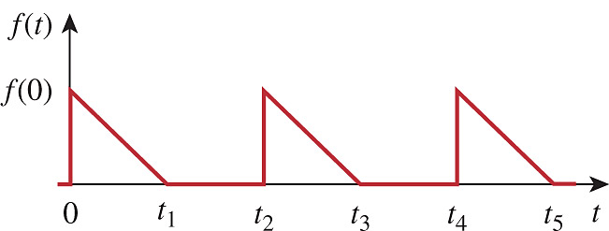

Figure 17.51
For Prob. 17.8.

